**Homework 2**

**Ex.1**

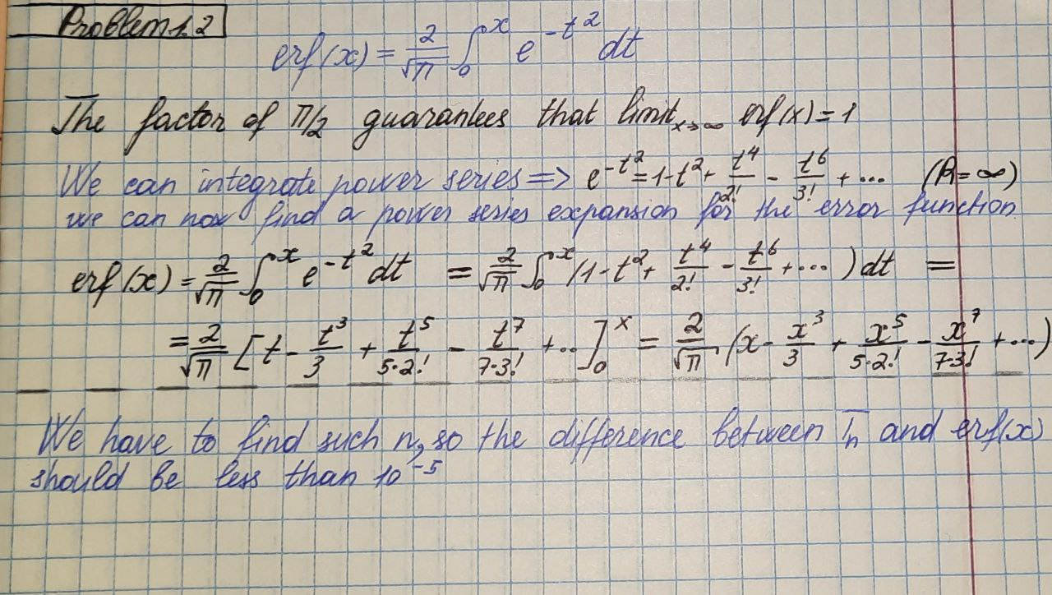

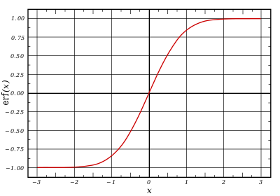

**Ex.2**

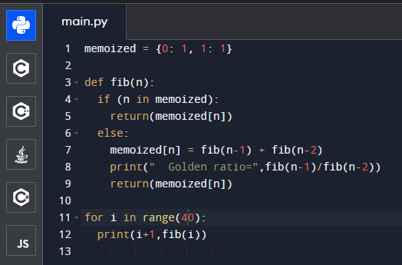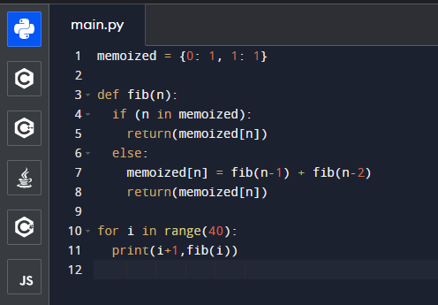

The ratio of successive Fibonacci numbers approaches the golden ratio. Here’s a program to explore this connection.

Program that generates Fibonacci numbers

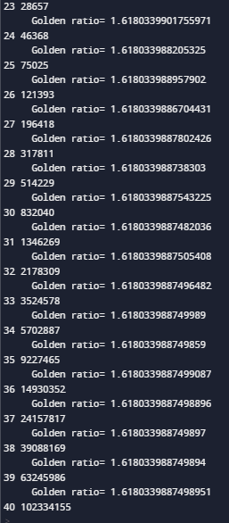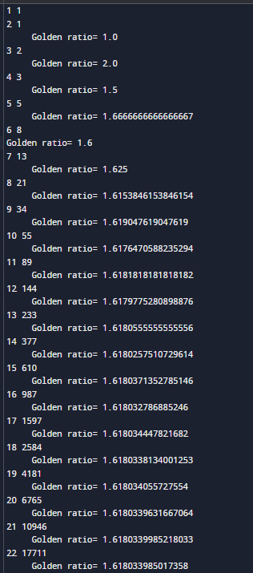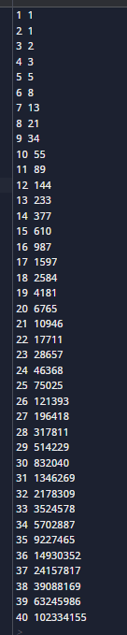

Thus we have found that the ratio of successive terms of a Fibonacci sequence a_{n+1}/a_n, which is equal to b_n/a_n, converges to the Golden Ratio.

**Ex.3**

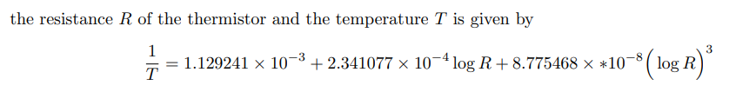

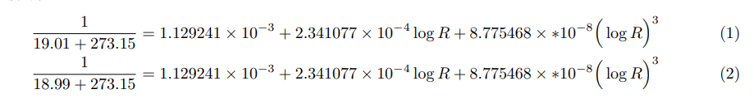

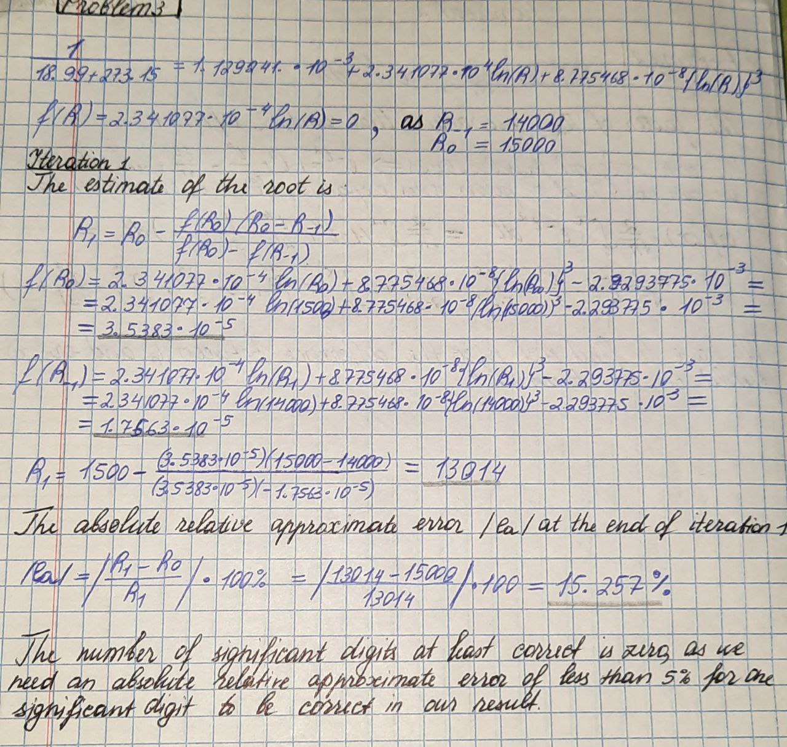

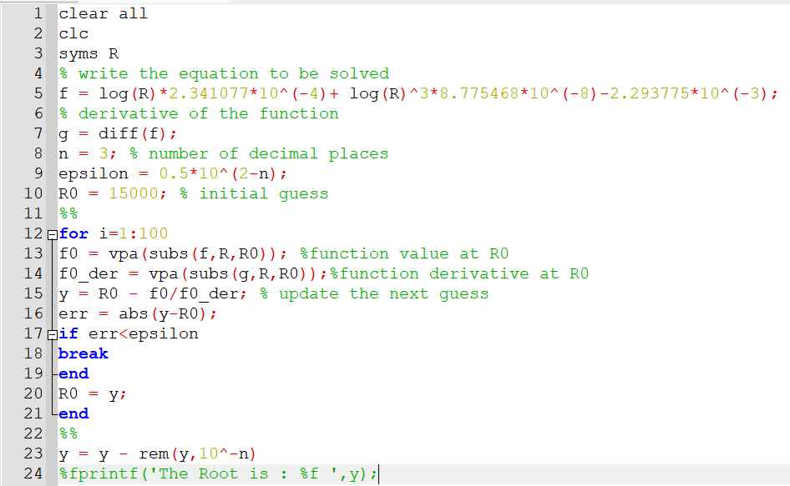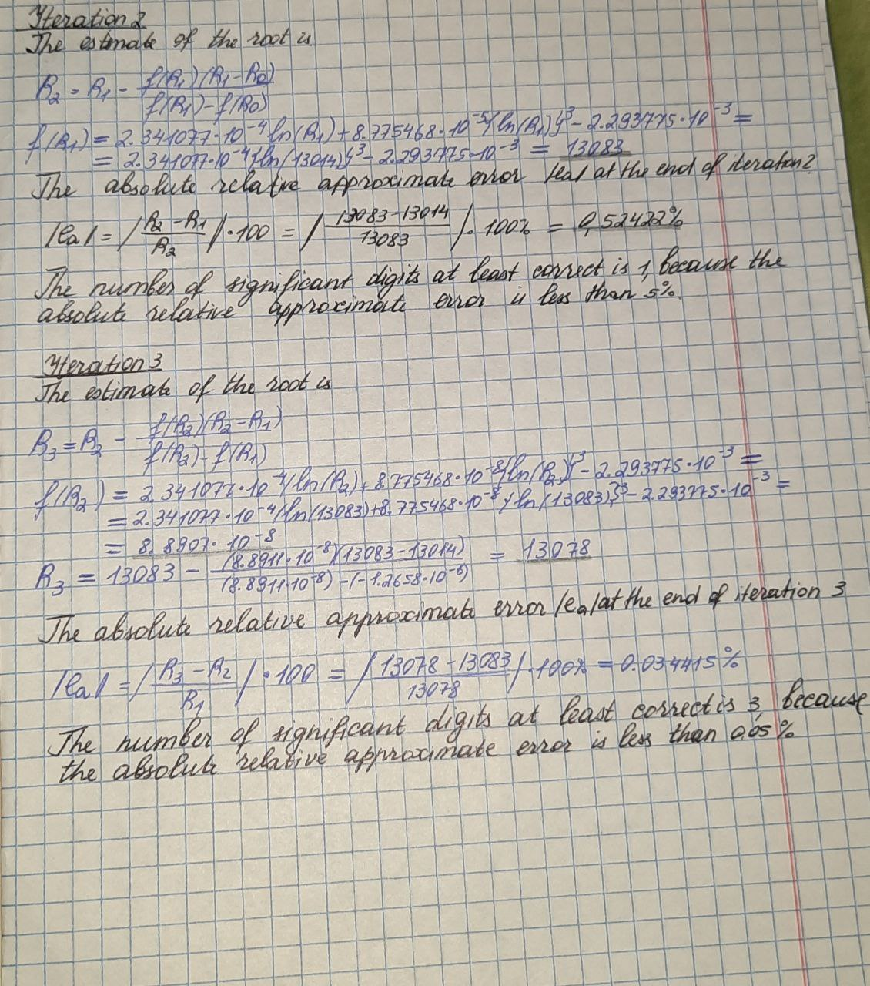

Ex.3 Matlab

**Ex.4**

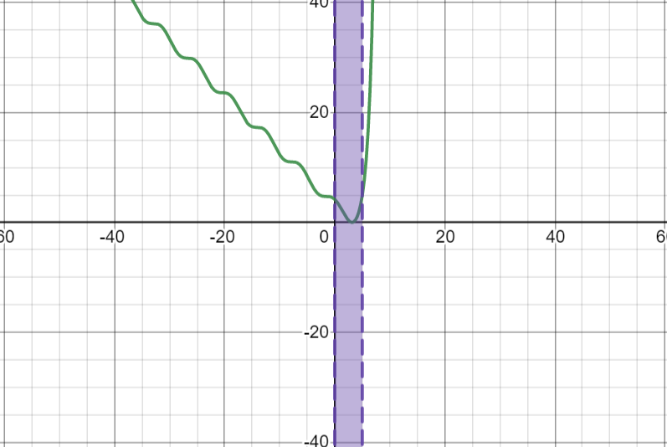

Order of convergence= 1.9617575539126844

It tends to 2 . It is quadratic.

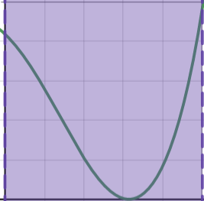

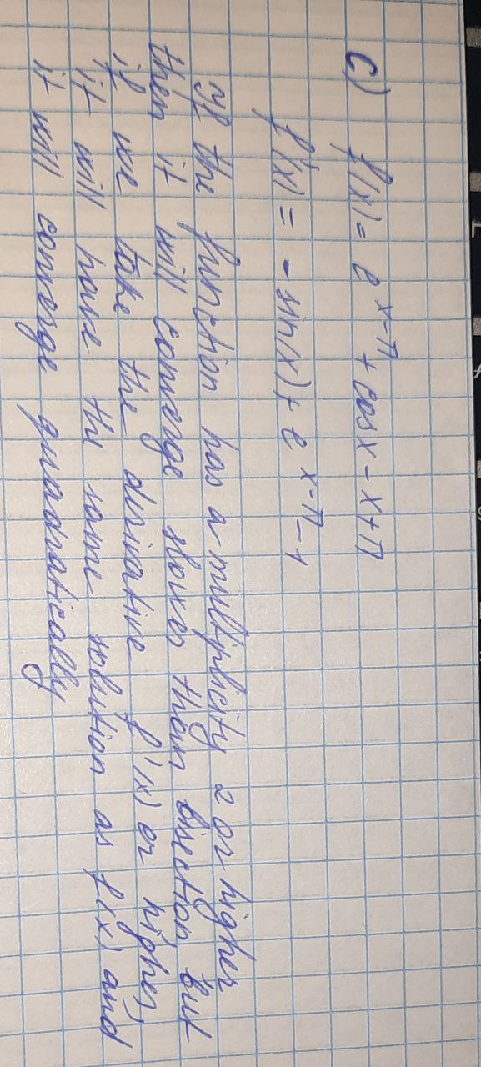

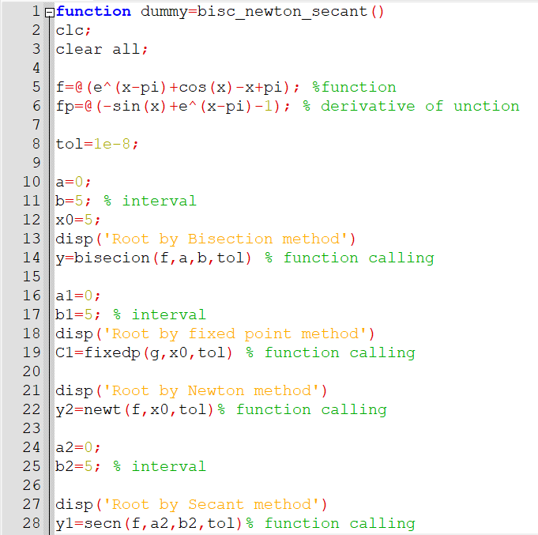

**Ex.5**

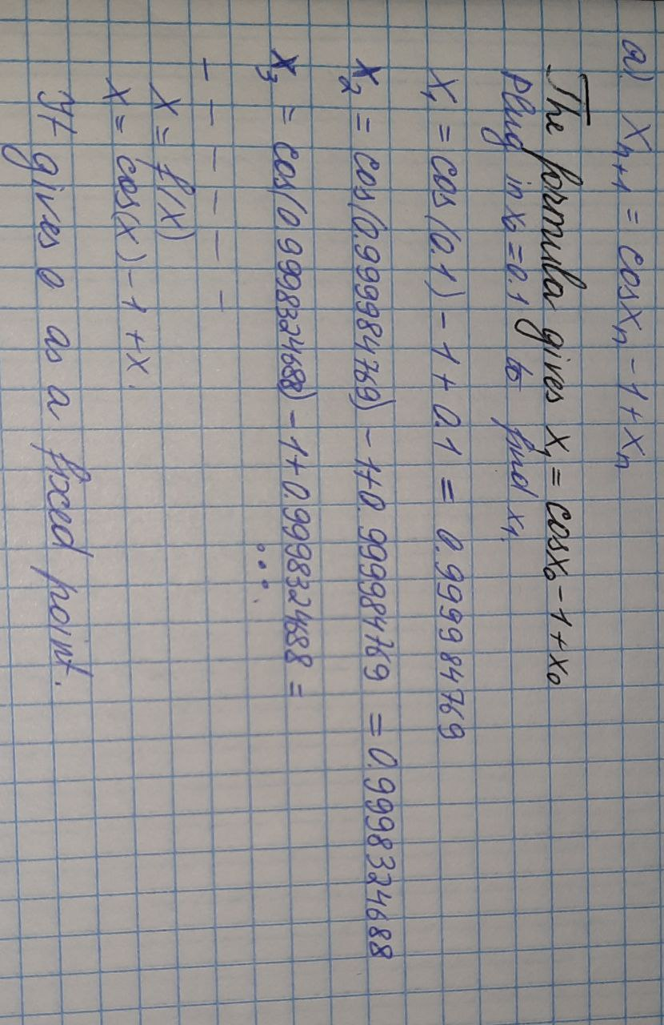

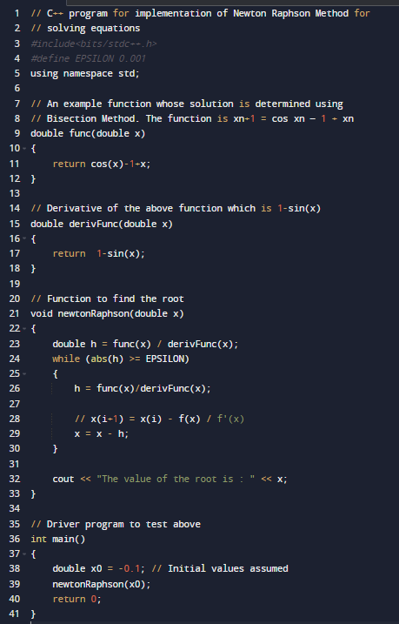

**Ex.6**

$$λn=\frac{x_{n} -x_{n-1}}{x_{n-1} -x_{n-2}}$$

|  |  |  |  |
| --- | --- | --- | --- |
| *n* | *xn* | *xn* − *xn−*1 | λn |
| 0 | 2*.*0 |  |  |
| 1 | 2*.*1248 | 0*.*124834 |  |
| 2 | 2*.*2148 | 0*.*089944 | 0,720705 |
| 3 | 2*.*2805 | 0*.*065698 | 0.72997777 |
| 4 | 2*.*3289 | 0*.*048386 | 0.736468797 |
| 5 | 2*.*3647 | 0*.*035827 | 0,74022727272 |
| 6 | 2*.*3913 | 0*.*026624 | 0.74567669172 |
| 7 | 2*.*4111 | 0*.*019835 | 0.74567669172 |
| 8 | 2*.*4260 | 0*.*014803 | 0,747626262 |
| 9 | 2*.*4370 | 0*.*011062 | 0,74224161073 |
| 10 | 2*.*4453 | 0*.*0082745 | 0,752227 |

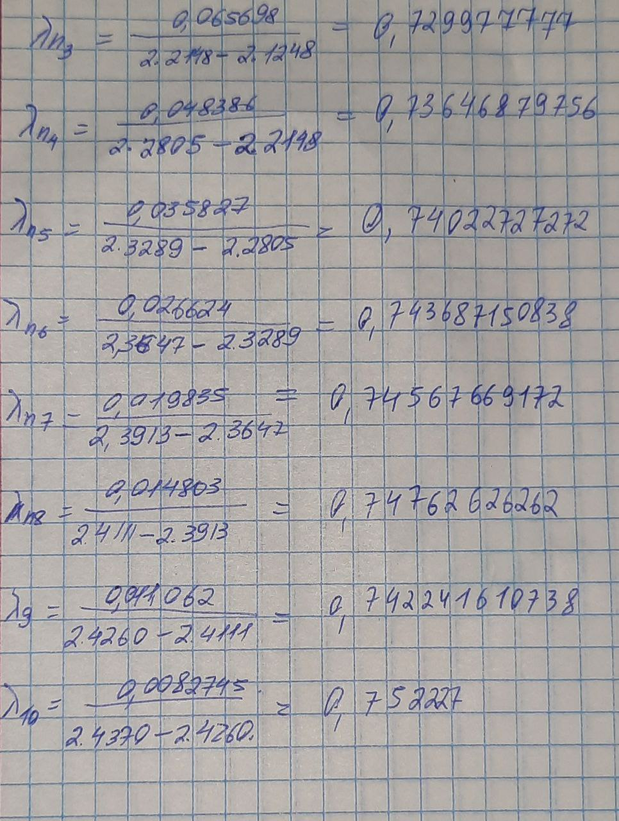

a)An iterative method is called convergent if the corresponding sequence converges for given initial approximations. Out function is convergent because it tends to the initial value 2.

b) Yes.

c) When the condition is satisfied, Newton's method converges, and it also converges faster than almost any other alternative iteration scheme based on other methods of coverting the original f(x) to a function with a fixed point.

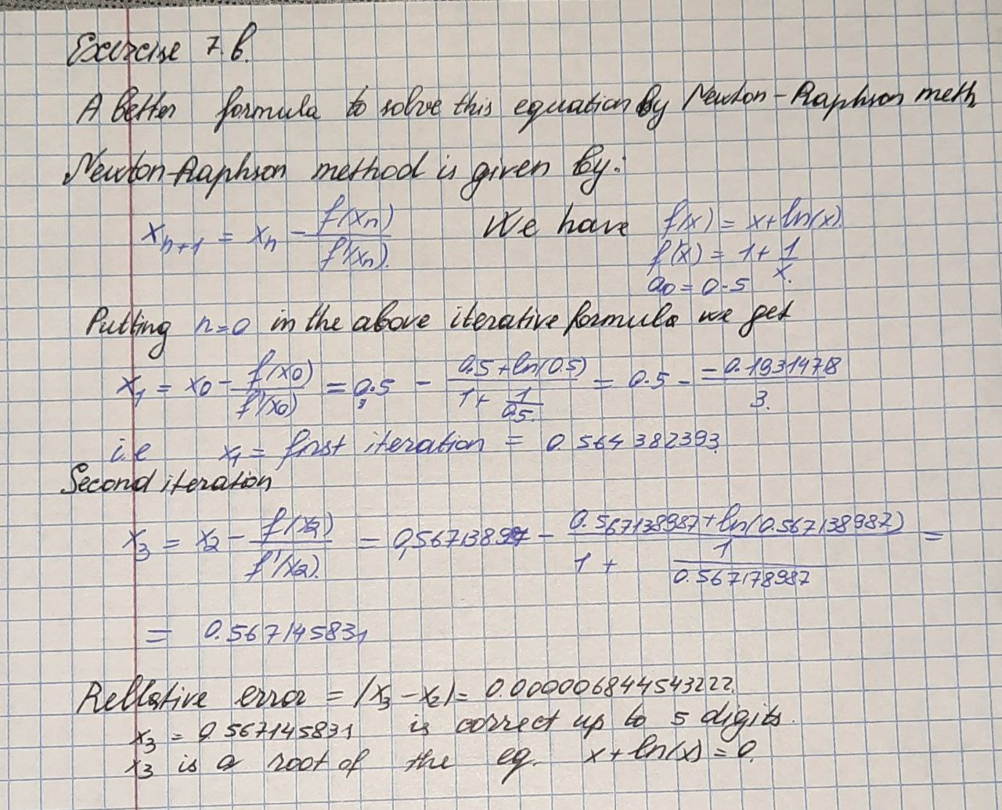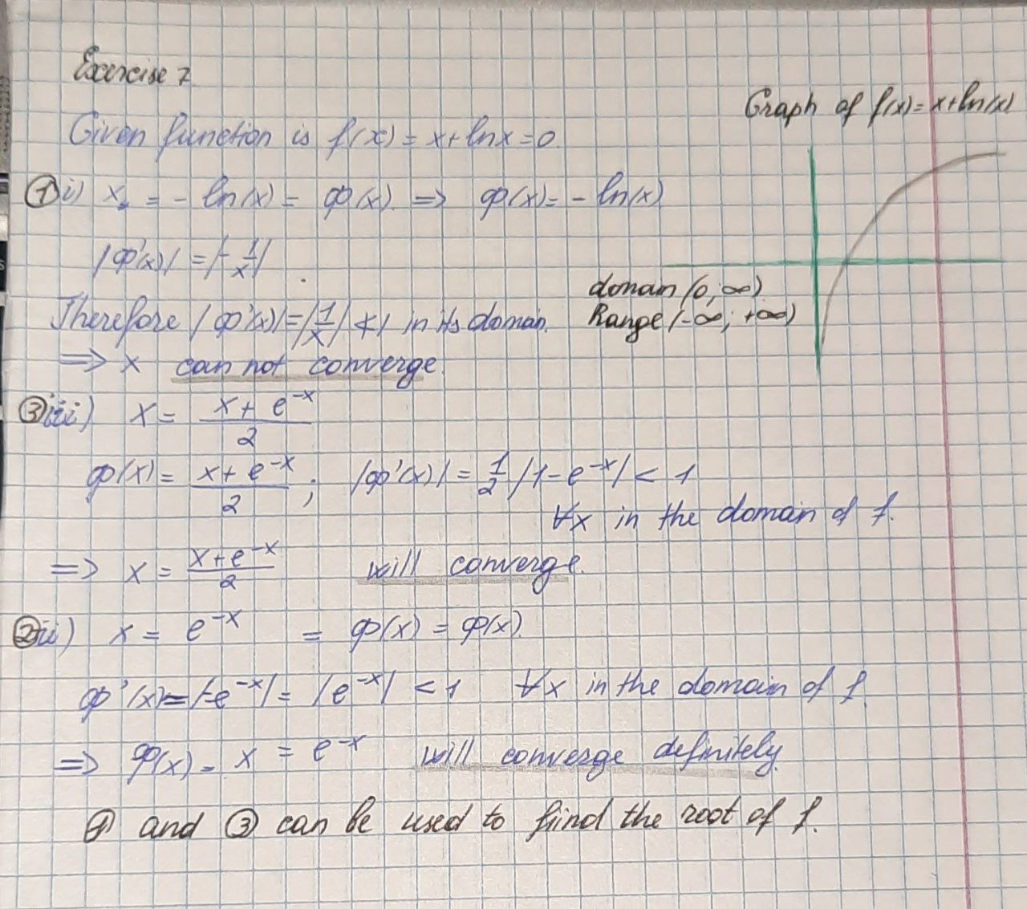**Ex.7**

**Ex.9**

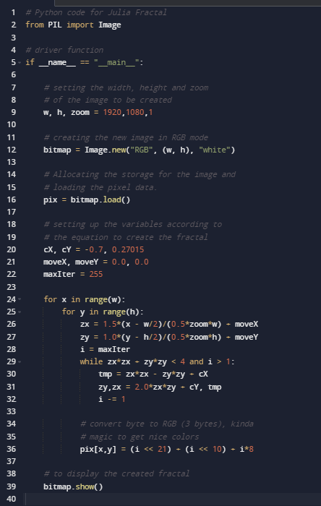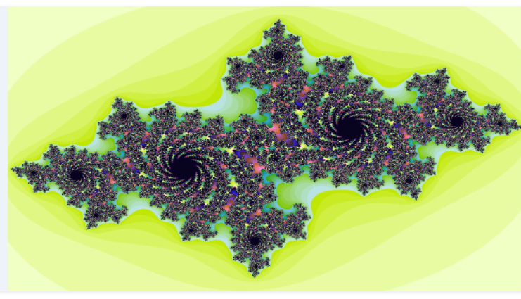

**Ex.8**

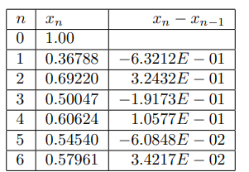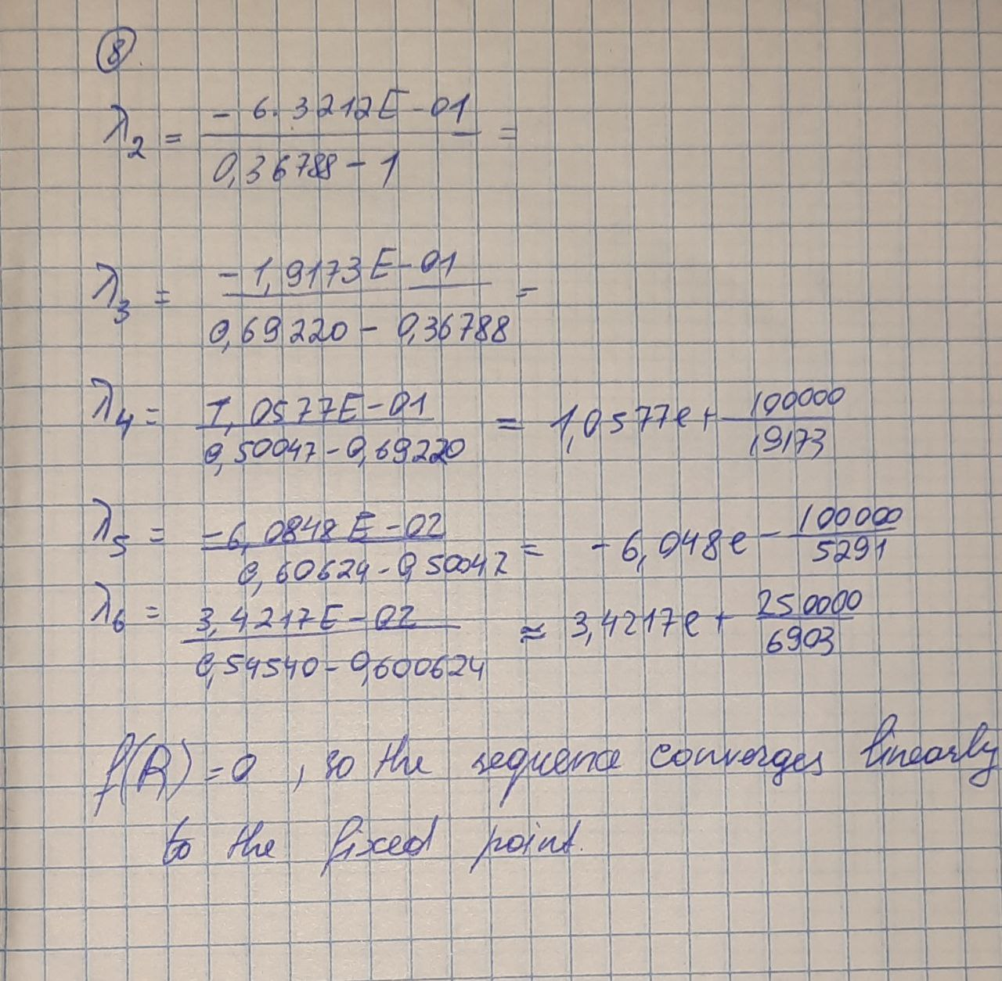

We can also use Aitken extrapolation formula